

INFORMATION TECHNOLOGY EDUCATION DEPARTMENT

ITPROG2
(Computer Programming 2 for IT)

EXERCISE
6

File Handling

score

Justine Guillermo  Name of Student | Jay-Ar Lalata  Name of Professor
02/22/19  Date Performed | Date Submitted

- OBJECTIVES:
At the end of the experiment students must be able to:

Cognitive
- Define C++ libraries for file handling

Psychomotor:
- Open and close a file in a C++ program

Affective
- Appreciate the concept behind this experiment.

- BACKGROUND INFORMATION
To perform file processing in C++, header files <iostream> and <fstream> must be included in your C++ source file.
Data Type | Description
ofstream | This data type represents the output file stream and is used to create files and to write information to files.
ifstream | This data type represents the input file stream and is used to read information from files.
fstream | This data type represents the file stream generally, and has the capabilities of both ofstream and ifstream which means it can create files, write information to files, and read information from files.
This requires another standard C++ library called fstream, which defines three new data types:

LABORATORY PROCEDURE:

- Create a folder in C:/H: named myfiles.
- Encode each of the programs and illustrate the result.

Note: Snip the contents of the file/s stated in the program and paste it in the Output portion. Also, snip the screen output.

Program No.1(save as fileex1)

//this program test for an existence of a file
#include<iostream>
#include <fstream>
#include<stdlib.h>
#include<cstring>

using namespace std;

int main()
{char file_name[15];
char path[20]="C:\\myfiles\\";

cout<<"Enter file name(maximum of 10 characters\n"
<<"with three character extension\n"
<<"Example: sample.txt"<<endl;
cin>>file_name;
cout<<"Ok! i will edit your file "<<file_name<<endl;

ofstream on_stream;

on_stream.open(strcat(path,file_name));

if(on_stream.fail())
{
cout<<"Input file opening failed.";
exit(1);
}
on_stream<<"The file content is this message.";
cout<<"File created successfully.";
on_stream.close();
return 0;
}

Output:

Content of <inputted_file_name>.txt
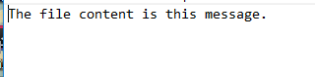

Screen Output:
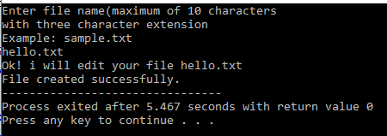

Program No.2(save as fileex2)

// This program obtains the size of a file
//Inside the folder create example.txt which contains the following: (see picture)

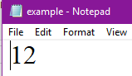
#include<iostream>
#include <fstream>
using namespace std;

const char *filename = “C:\\myfiles\\example.txt”;
int main( ) {
long int I,m;
ifstream file(filename,ios::in | ios::binary);
I = file.tellg();
file.seekg(0,ios::end);
m = file.tellg( );
file.close();
cout<<”size of “<<filename;
cout<<” is “<<(m-I)<<” bytes.\n”;

file.close();
return 0;
}

Output:

Content of example.txt
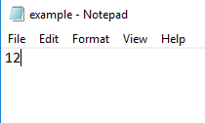

Screen Output:
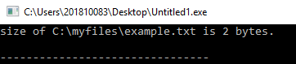

Program No.3(save as fileex3)

//Inside the folder create infile.txt which contains the following: (see picture)
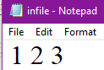

#include<iostream>
#include <fstream>
#include<stdlib.h>
using namespace std;

int main()
{
ifstream in;
ofstream out;

in.open("C://myfiles//infile.txt");
if(in.fail())
{
cout<<"Input file opening failed.\n";
exit(1);
}

out.open("C://myfiles//outfile.txt");
if(out.fail())
{
cout<<"Output file opening failed.\n";
exit(1);
}

int first, second, third;
in>>first>>second>>third;
out<<"The sum of the first three numbers\n"
<<"is "<<(first+second+third)<<endl;

in.close();
out.close();
return 0;
}

Output:

Content of infile.txt
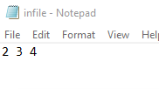

Content of outfile.txt
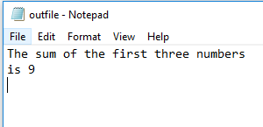

Screen Output:
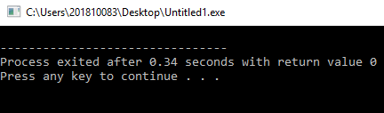

Program No. 4(save as fileex4)

#include<iostream>
#include <fstream>
#include<stdlib.h>
#include<ctype.h>
using namespace std;

int main()
{
ofstream out;

out.open("C:\\myfiles\\record.txt");
if(out.fail())
{
cout<<"Output file opening failed.\n";
exit(1);
}
int flag=1;
char choice;
struct {
char name[20];
char number[13];
} person;

while(flag)
{
cout<<"Input phone directory entry.\n"
<<"Name : ";
cin>>ws;
cin.getline(person.name,20);
cout<<"Phone Number: ";
cin.getline(person.number,13);
out<<person.name<<" "<<person.number<<"\n";
cout<<"Another entry [Y/N]?";
cin>>choice;
if(toupper(choice)=='Y')
flag=1;
else
flag=0;

}
out.close();
return 0;
}

Output:

Content of record.txt

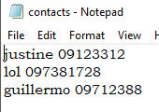

Screen Output:
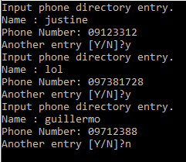

Problem:

Considering the file directory created in Program no. 4, write a program, which accepts the name of a person and searches the file for the corresponding phone number.

Note: to implement this kind of program the eof( ) function can be used. A file may be any length so we need a way to detect the end of a file. The eof function returns one(1) if the file pointer is at the end of file, and zero (0) if there is still more data to be read from the file. Consider the following statement as an example:

result=eof(FileInput);

Source Code:
//this program will add and can search the contents in the txt file contacts
#include<iostream>
#include <fstream>
#include <cstring>
using namespace std;
int main();//prototype

void add (){
struct {
char name[20];
char number[13];
} person;
int flag=1;
char choice;
ofstream out;
out.open("C:\\Users\\Justine Guillermo\\Desktop\\System\\contacts.txt",ios::app);
while(flag){
cout<<"Input phone directory entry.\n"<<"Name : ";
cin>>ws;
cin.getline(person.name,20);
cout<<"Phone Number: ";
cin.getline(person.number,13);
out<<person.name<<" "<<person.number<<"\n";
cout<<"Another entry [Y/N]?";
cin>>choice;
if(toupper(choice)=='Y')
flag=1;
else
flag=0;
}
out.close();
main();
}
void search (){
ifstream file;
int flag=1;
char choice;
string x,name;
int i;

cout << "search a name: ";
cin >>name ; //user inputs the name to be searched
file.open("C:\\Users\\Justine Guillermo\\Desktop\\System\\contacts.txt",ios::in);
while(!file.eof()){//scans the whole note pad until the end
getline(file,x);// gets one line in the file in contacts.txt
//every time a getline is used the compiler goes to the next line of the notepad.
for(i = 0; name[i] != '\0'; ++i);//counts the length of the string "name"
if (x.substr(0,i)==name) //filter if the searched name is equals to the string x
cout << x <<endl;
}
cout<<"Another search [Y/N]?";
cin>>choice;
if(toupper(choice)=='Y')
flag=1;
else
flag=0;

file.close();
main();
}
int main(){

int ch1;
int f=1;
char ch2;
do {
cout <<"[1] Create a new contact"<<"\n"<<"[2] Search a name"<<"\n"<<"[3]Exit"<<"\n"<<"Choice:";
cin >> ch1;
switch (ch1){
case 1:
add();
break;

case 2:
search();
break;
case 3;

}
cout << "do you want to choose again? [Y/N] ";
cin >> ch2;
if(toupper(ch2)=='Y')
f=1;
else
f=0;
}while(f);

return 0;
}
Output:
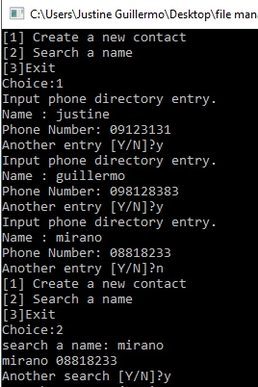

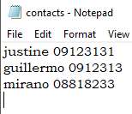

Note: List the contents of the output file.

- QUESTION AND ANSWER:

1. What library you used to comply with the program requirements?

#include<iostream>
For basic input output.
#include <fstream>
For opening files .
#include <cstring>
For string functions to be used.

2. Can we open a file before writing it? Explain your answer.

Yes we need to open the file before writing on it because if you don’t open it the file won’t be writeable or readable.

V. ASSESSMENT

Department | Information Technology
Subject Code | ITPROG2
Description | COMPUTER PROGRAMMING 2 for IT
Term/Academic Year

Note: The following rubrics/metrics will be used to grade students’ output in the lab Exercise 4.
Trait | (Excellent) | (Good) | (Fair) | (Poor)
Requirement Specification (30pts) | Able to identify correctly all input and output and provide alternative.  (28-20pts) | Able to identify correctly all input and output  (25-17pts) | Able to identify only one input or output  (22-14pts) | Unable to identify any input and output  (20-11pts)
Data type (20pts) | Able to apply required data type or data structure and produce correct results (18-20pts) | Able to apply required data type or data structure and produce partially correct results (15-17pts) | Able to identify required data type or data structure but does apply correctly (12-14pts) | Unable to identify required data type  (9-11pts)
Input Validation (20pts) | The program works and meets all specifications. Does exception al checking for errors and out-of- range data (18-20pts) | The program works and meets all specifications. Does some checking for errors and outof- range data (15-17pts) | The program produces correct results but does not display correctly Does not check for errors and outof- range data (12-14pts) | The program produce s incorrect results (9-11pts)
Free from syntax, logic, and runtime errors (10pts) | Unable to run program (10pts) | Able to run program but have logic error (8-9pts) | Able to run program correctly without any logic error and display inappropri ate output (6-7pts) | Able to run program correctly without any logic error and display appropriate output (5pts)
Delivery (10pts) | The program was delivered on time (10pts) | The program was delivered after 5 minutes from the time required. (8-9pts) | The program was delivered after 10 minutes from the time required. (6-7pts) | The program was delivered after 15 (or more) minutes from the time required. (5pts)
Use of Comments  (10pts) | Specific purpose is noted for each function, control structure, input requirements, and output results. (10pts) | Specific purpose is noted for each function and control structure. (8-9pts) | Purpose is noted for each function. (6-7pts) | No comments included. (5pts)

Topic | File Handling
Lab Activity No | 4
Lab Activity | Accessing files from C++
CLO | 1,2
Requirement Specification (30pts)
Data type (20pts)
Input Validation (20pts)
Free from syntax, logic, and runtime errors (10pts)
Delivery (10pts)
Use of Comments (10pts)
TOTAL

